computer science - C++

Lesson 33: Linked-List Algorithms

OBJECTIVES: The student will code a function to insert data into a linear linked list in ordered fashion, based on a key field.

The student will code a function to search for a specific value in an ordered linked list.

The student will code a function to delete information from an ordered linked list.

ACTIVITIES/TIME: Four Days:
Day one: Presentation - 50 minutes
Days two - four: Lab Exercise

MATERIALS: Student Outline O.A.33.1
Lab Exercise L.A.33.1, OrderedList
Answer Sheet L.A.33.1

REFERENCES: Adams, Joel, Sanford Leestma, and Larry Nyhoff. C++, An Introduction to Computing. Chapter 15.

Deitel, Harvey M. and Paul J. Deitel. C++ How to Program. Chapter 15.

Savitch, Walter. Problem Solving with C++. Chapter 14.

INSTRUCTOR
NOTES: This lesson and the corresponding lab exercise, L.A.33.1, OrderedList will demand greater proficiency with linked lists by specifying the linked list to be built in ordered fashion. The student outline is short but the lab exercise is long. To speed up the process, it might be necessary to provide a program shell consisting of the main menu; the testing functions; and stubbed out modules, which students will complete. The source code, ordShell.cpp, which has omitted the key algorithms, is included on disk. The program will read a data file hard-coded into the readData function, however the linked list will be created out-of-order.

Be careful when you decide which data file to test as the recursive printBackward will over-extend the memory heap on most systems when testing large linked lists. This algorithm is a short, but worthwhile exercise. The largest data file recommended for testing is (file50.txt).

You might consider preparing a very short data file, (file3.txt), which contains only 3 id/inv pairs. This will test the special cases of deleting at the end, the front, and a list with one node. Have students test their algorithm on this short list at home, but still require a more general run output using (file10.txt) or (file20.txt).

Student Outline

Lesson 33: Linked-List Algorithms

INTRODUCTION: The linked list in this lesson will have the following special characteristic: the random order of the incoming data will be stored in ordered fashion based on a key field. After creating the linked list, a variety of algorithms will be discussed and solved.

The key topics for this lesson are:

A. Building an Ordered Linked List
B. Linked-List Algorithms
C. Static vs. Dynamic Data Structures

VOCABULARY: INTERNAL POINTER EXTERNAL POINTER

DISCUSSION: A. Building an Ordered Linked List

1. If data is supplied in unordered fashion, building an ordered linked list becomes a harder problem. Consider the following cases for inserting a new value into the linked list:

a. Insert the new value into an empty list.
b. Insert the new value at the front of the list.
c. Insert the new value at the tail of the list.
d. Insert the new value between two nodes.

2. Suppose the data was supplied in this order:

42 6 95 12 <eof>

The resulting ordered linked list looks like this:

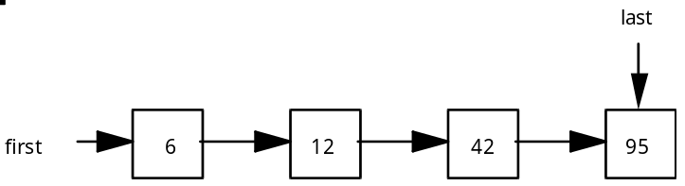

3. Three of the cases are easy to identify and solve: the empty list case, placing the new value at the front of the list, or adding the value to the end of the list.

4. To assist us in our discussion of linked list algorithms, some definitions will be helpful. An internal pointer is one which exists inside a node. An internal pointer joins one node to the next in the linked list. An external pointer is one which points to a node from outside the list. Every linked data structure must have at least one external pointer which allows access to the data structure. Our linked list in the student outline has two external pointers, first and last.

5. Suppose a fifth value, 61, is to be inserted into the list. We can see in the diagram that it will go between the 42 and 95. To help the computer “see” this, we are going to use some helping external pointers, also called auxiliary pointers.

6. It is possible to find the attachment point using just one auxiliary pointer, but we will use two called temp and back. Using two external pointers makes the hookup easier. Finding the attachment point involves something like this:

while we haven't found the attachment point
{
back = temp; {move back up to temp}
temp = temp->next; {advance temp one node ahead}
}

For attaching the value 61, back and temp will end up pointing to these locations:

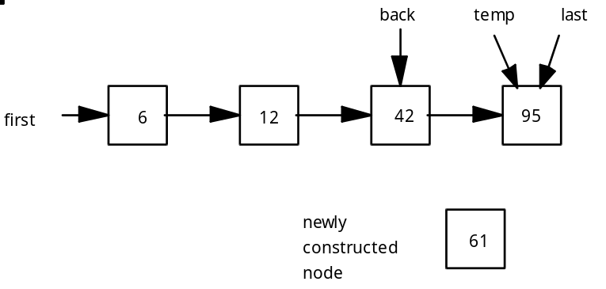

7. The code to invoke the struct constructor is left up to you.

B. Linked-List Algorithms

1. Searching an ordered linked list is a sequential search process. A linked list is not a random access data structure. You cannot jump to the middle of a linked list. Only sequential moves are possible. The search function could return a value or a pointer to that cell.

2. Deleting a value involves the following steps:
a. Locating the value (if it exists) to be deleted.
b. Rehooking pointers around the node to be deleted.
c. Applying delete to the unneeded memory location.

C. Static vs. Dynamic Data Structures

1. An apvector is a somewhat static data structure which has these advantages and disadvantages:

Advantages of apvector class Disadvantages of apvector class

1. Easy to implement and use.  2. Fast, random access feature.  3. Can be resized, but resizing is a linear algorithm. | 1. Memory is usually wasted.

2. A linked list, (LL), is a dynamic data structure which has these advantages and disadvantages.

Advantages of LL Disadvantages of LL

1. Memory is allocated when the program is run, therefore the data structure is only as big as it needs to be.  2. Memory is conserved. | 1. Each node of the list takes more memory.  2. Processing is slower.  3. The data structure is not random access.  4. Processing must be done in sequential order.

SUMMARY/REVIEW: We now have two different data structures to implement lists: vectors or linked lists using pointers. Each has its appropriate place in a programmer’s tool kit. We will discuss variations of singly linked lists in the next lesson.

ASSIGNMENT: Lab Exercise L.A.33.1, OrderedList

